Contents
2. Set passwords 7
3. Create isolated directories 7

Linux assignment
Task 1: System Monitoring Setup
Install and configure htop or nmon to monitor CPU, memory, and processes, using df and du for disk usage tracking, and identifying resource-intensive processes. Proper logging of system metrics and clear documentation of the setup are essential.
Steps taken to complete task 1
- Set-up VM on Oracle virtual box
- Connect the VM using Putty
- Update system
  - yum update -y
- Install useful tools
  - yum install vim wget curl net-tools -y
- Check IP (to use SSH later)
  - ip addr

ip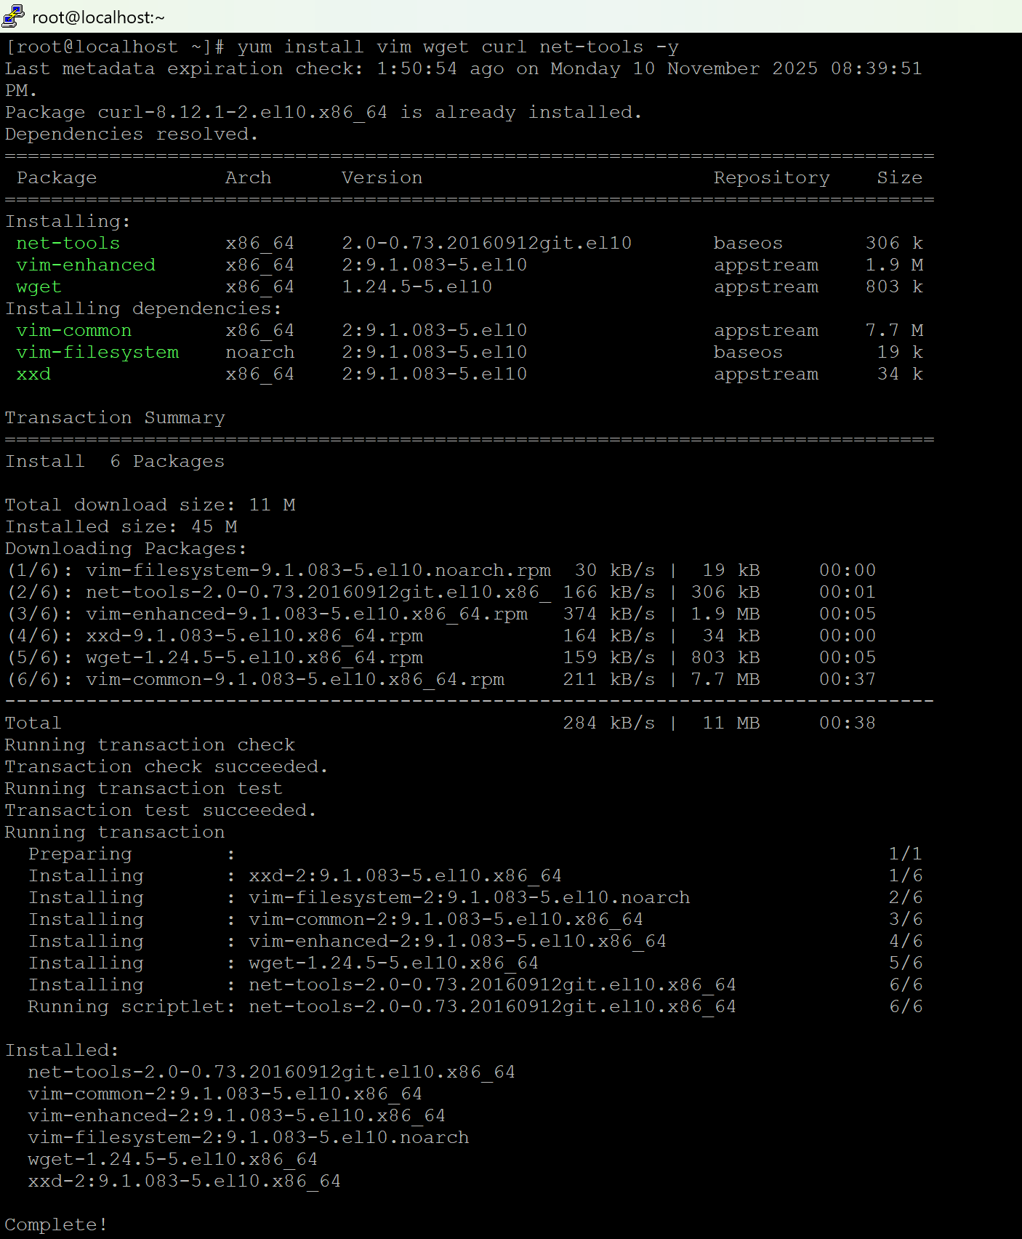

ip addr:
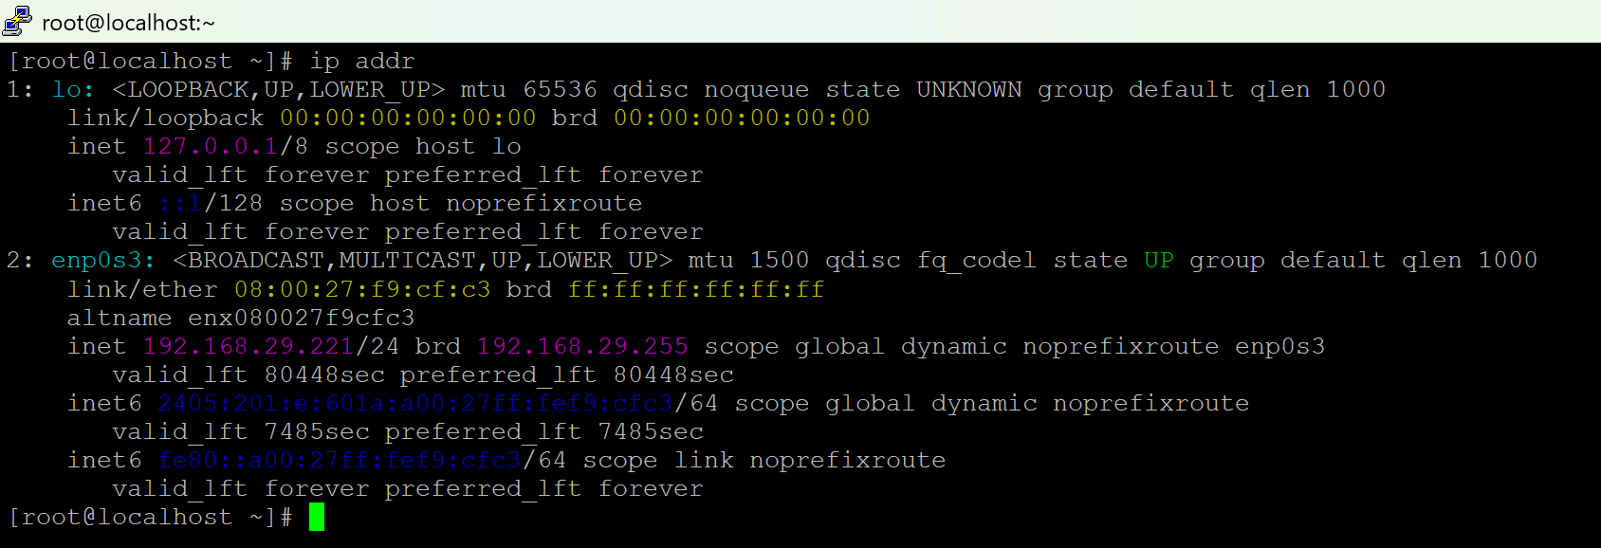

- TASK 1: System Monitoring Setup:
  - Install EPEL repo
    - yum install epel-release -y
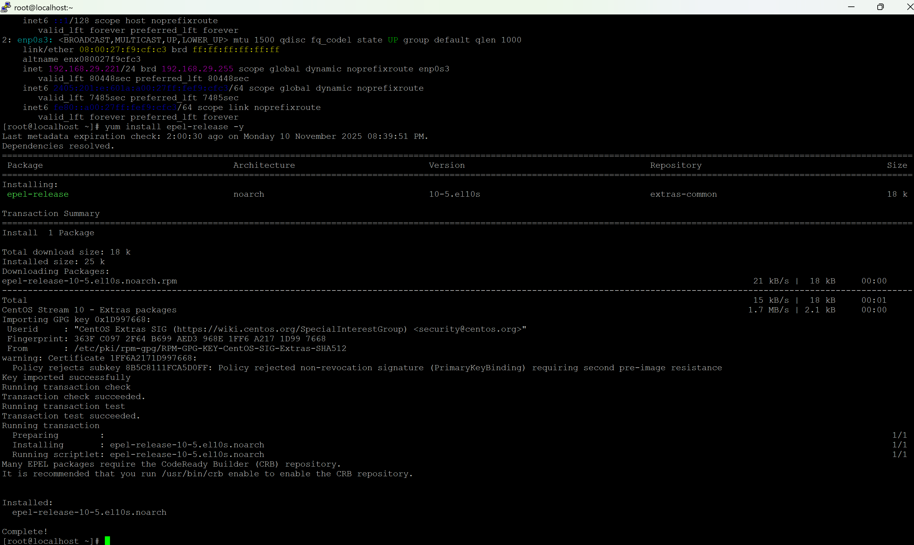

- Install monitoring tools
  - yum install htop nmon -y
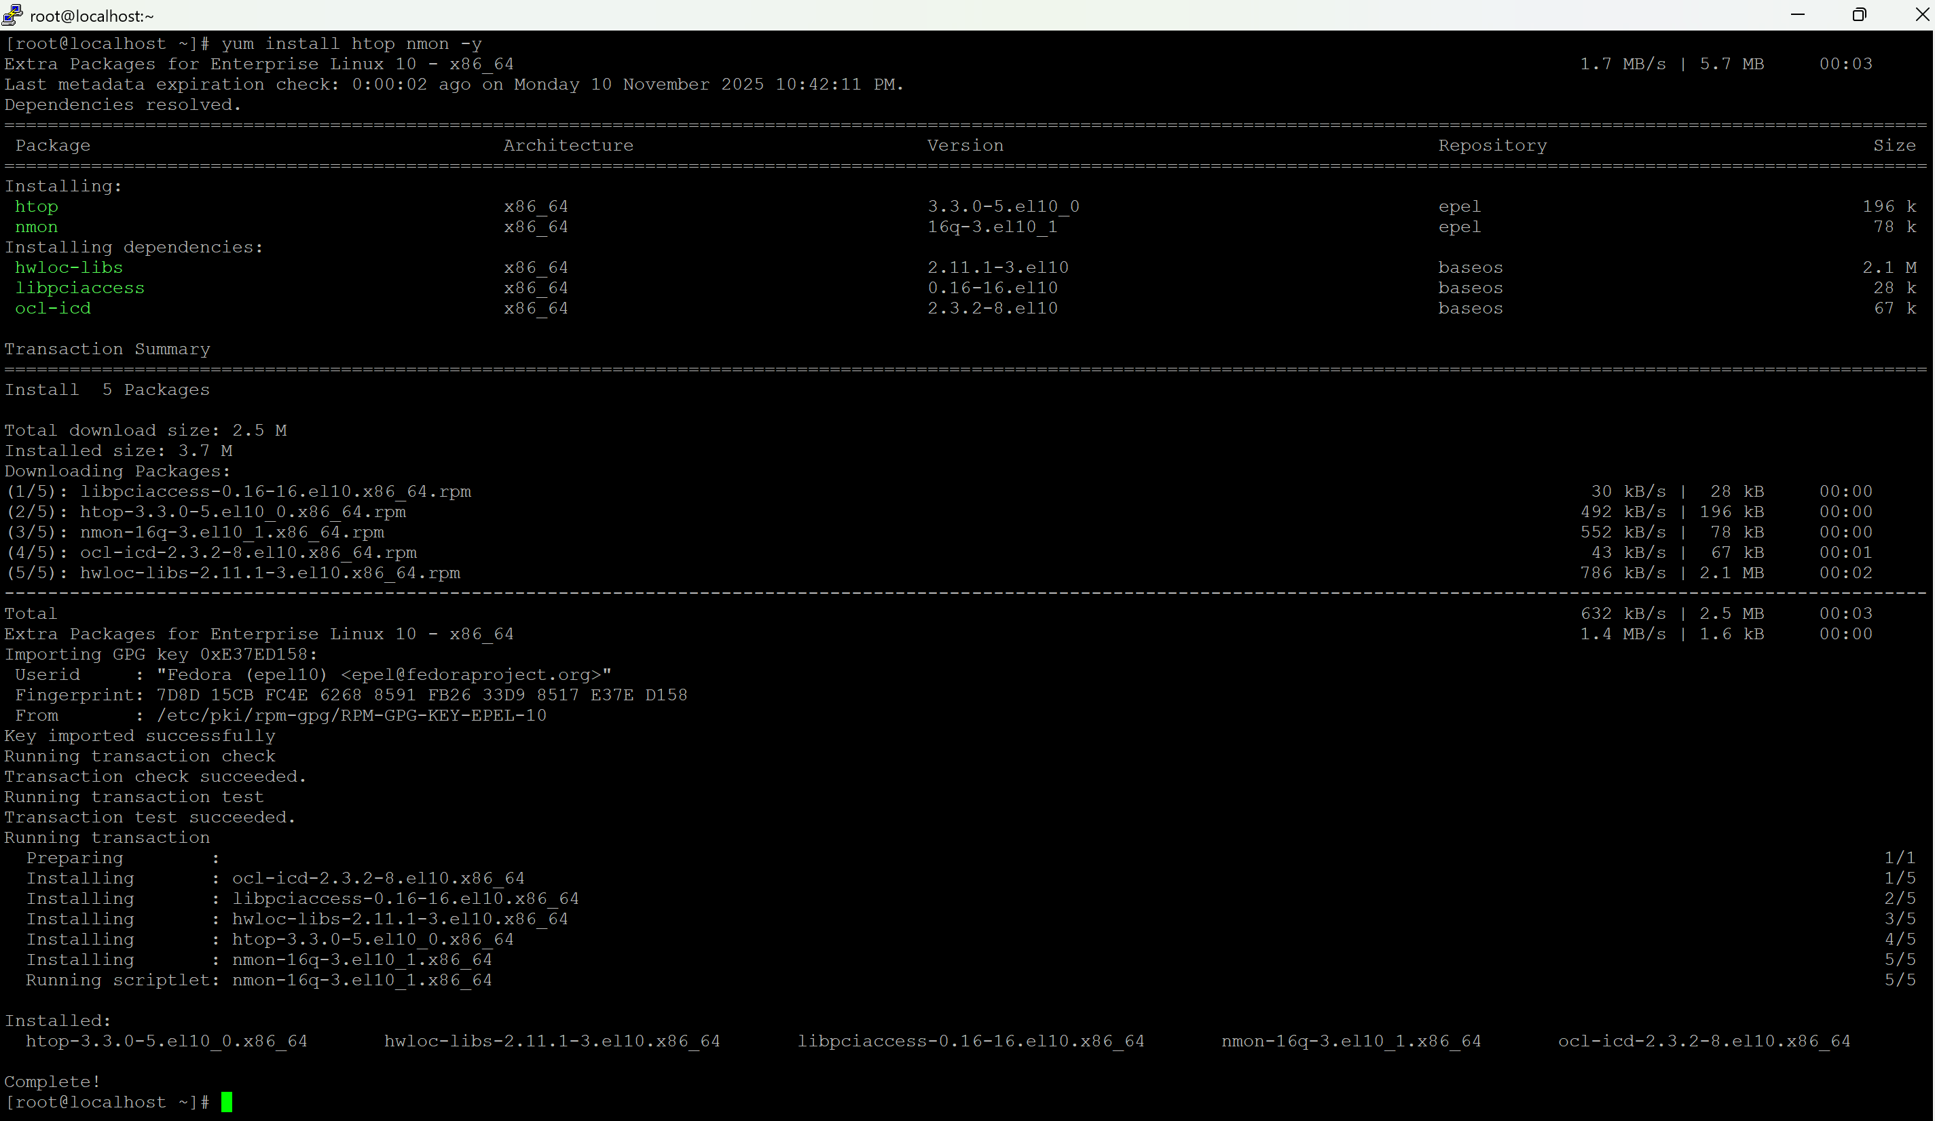
- Run monitoring tools manually (interactive)
  - Htop
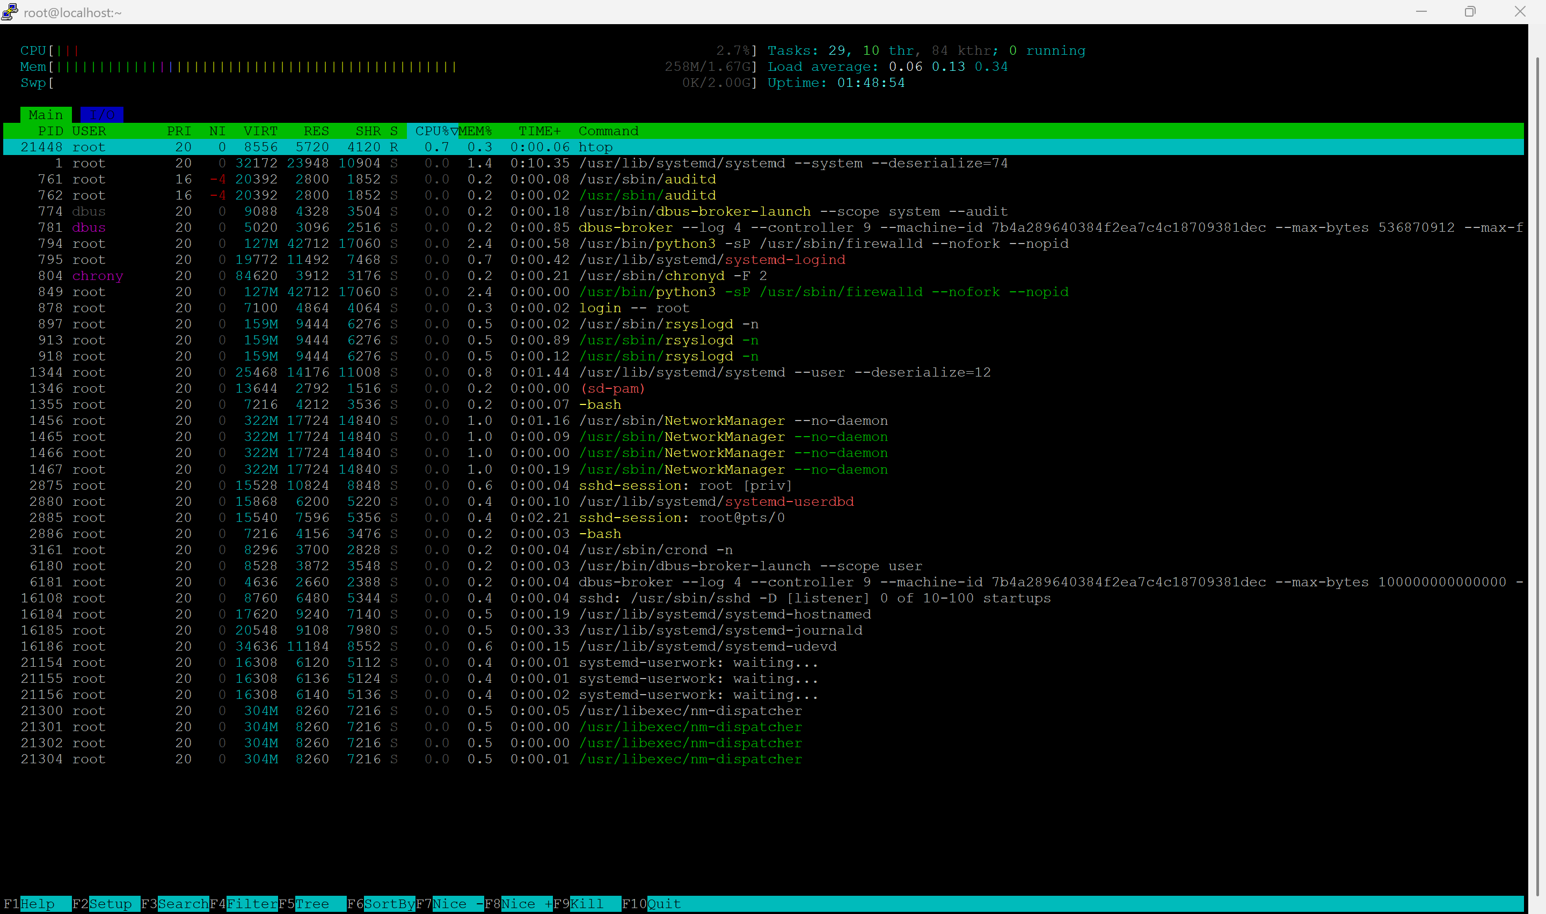

  - Nmon
    - CPU
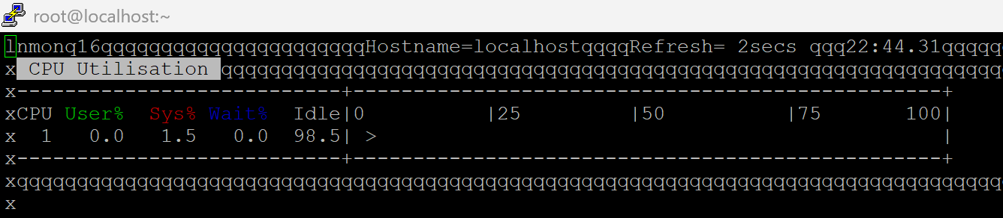

  - Nmon
    - Memory
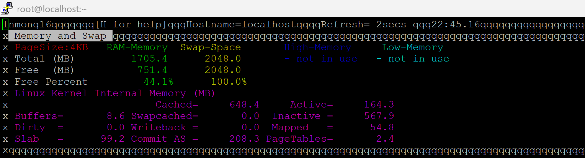

- Check disk usage
  - df -h
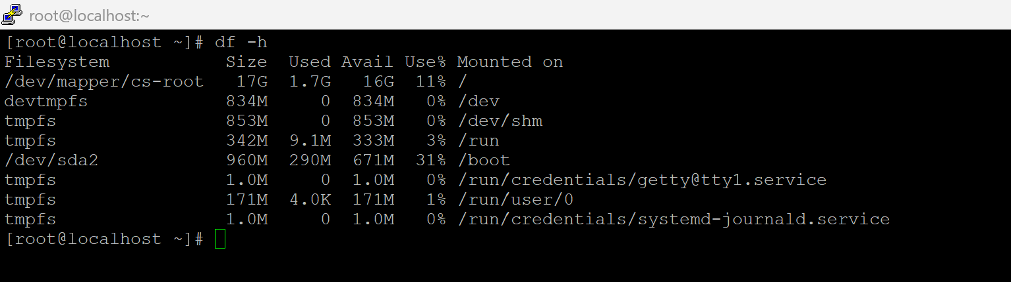

- Check directory size
  - du -sh /var/log
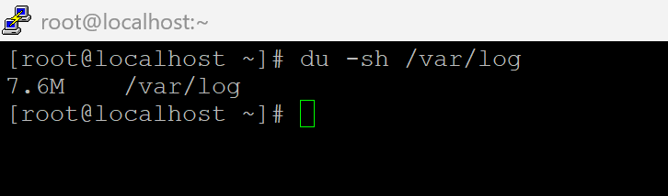

- Identify top memory-consuming processes
  - ps aux --sort=-%mem | head -10
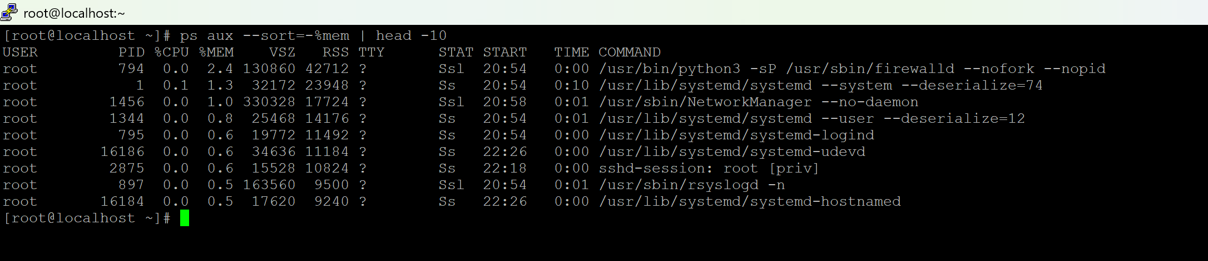
- Create monitoring logs folder
  - mkdir -p /var/log/monitoring

- Save system status to a log file (manual)
  - htop -n 1 > /var/log/monitoring/sys_monitor.log
  - df -h > /var/log/monitoring/disk_usage.log
  - ps aux --sort=-%cpu | head -10 > /var/log/monitoring/top_processes.log

- View logs
  - cat /var/log/monitoring/sys_monitor.log
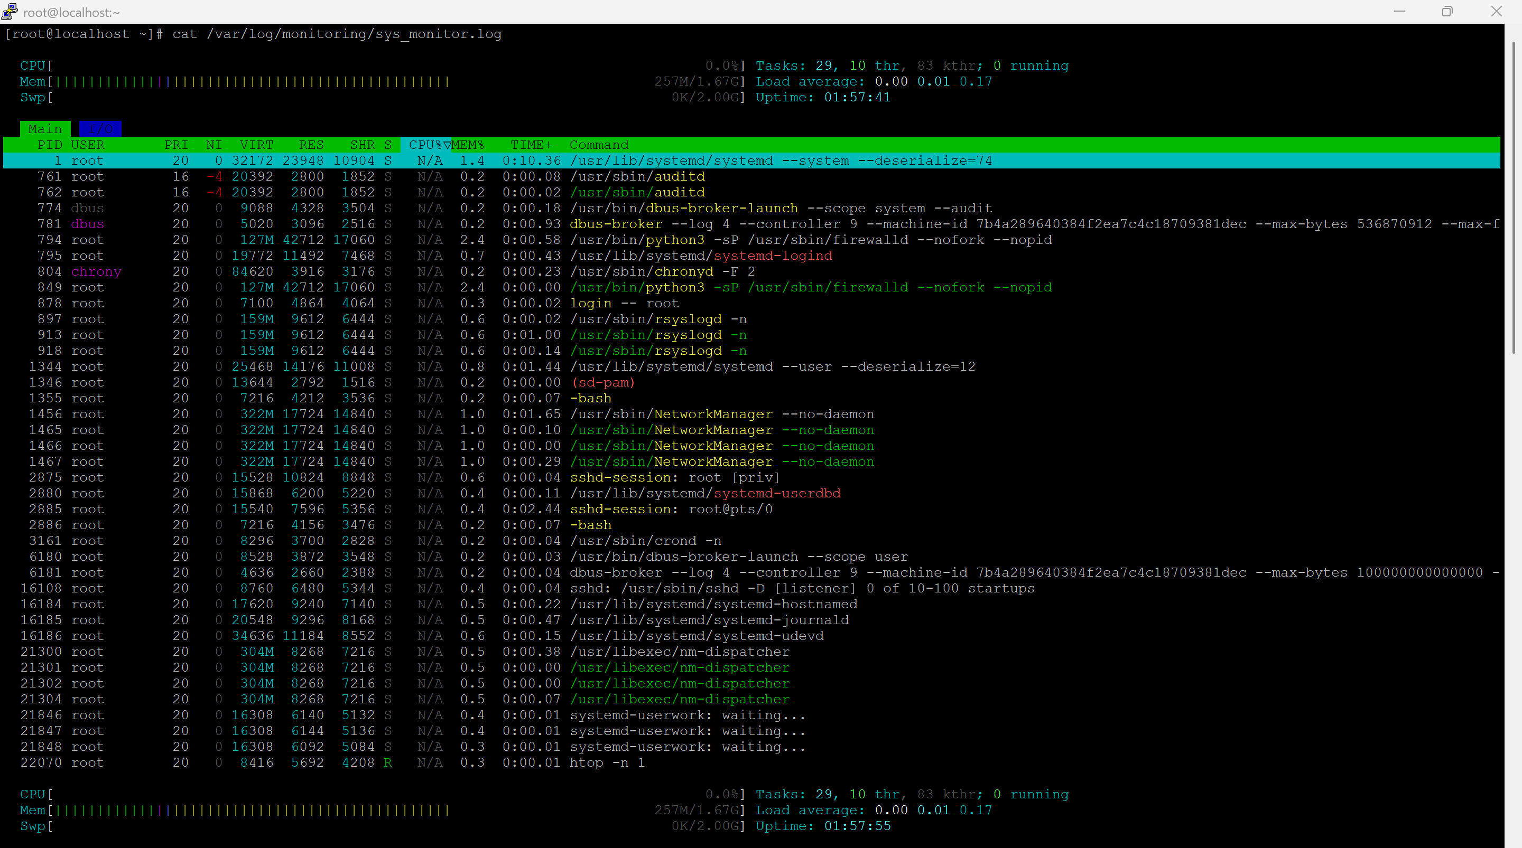

Task2 — User Management & Access Control
- Create users:
  - adduser Sarah
  - adduser Mike
- Set passwords
  - passwd Sarah
  - passwd Mike
- Create isolated directories
  - mkdir -p /home/Sarah/workspace
  - mkdir -p /home/Mike/workspace
- Assign ownership:
  - chown -R Sarah:Sarah /home/Sarah/workspace
  - chown -R Mike:Mike /home/Mike/workspace
- Restrict permissions (user-only access):
  - chmod 700 /home/Sarah/workspace
  - chmod 700 /home/Mike/workspace
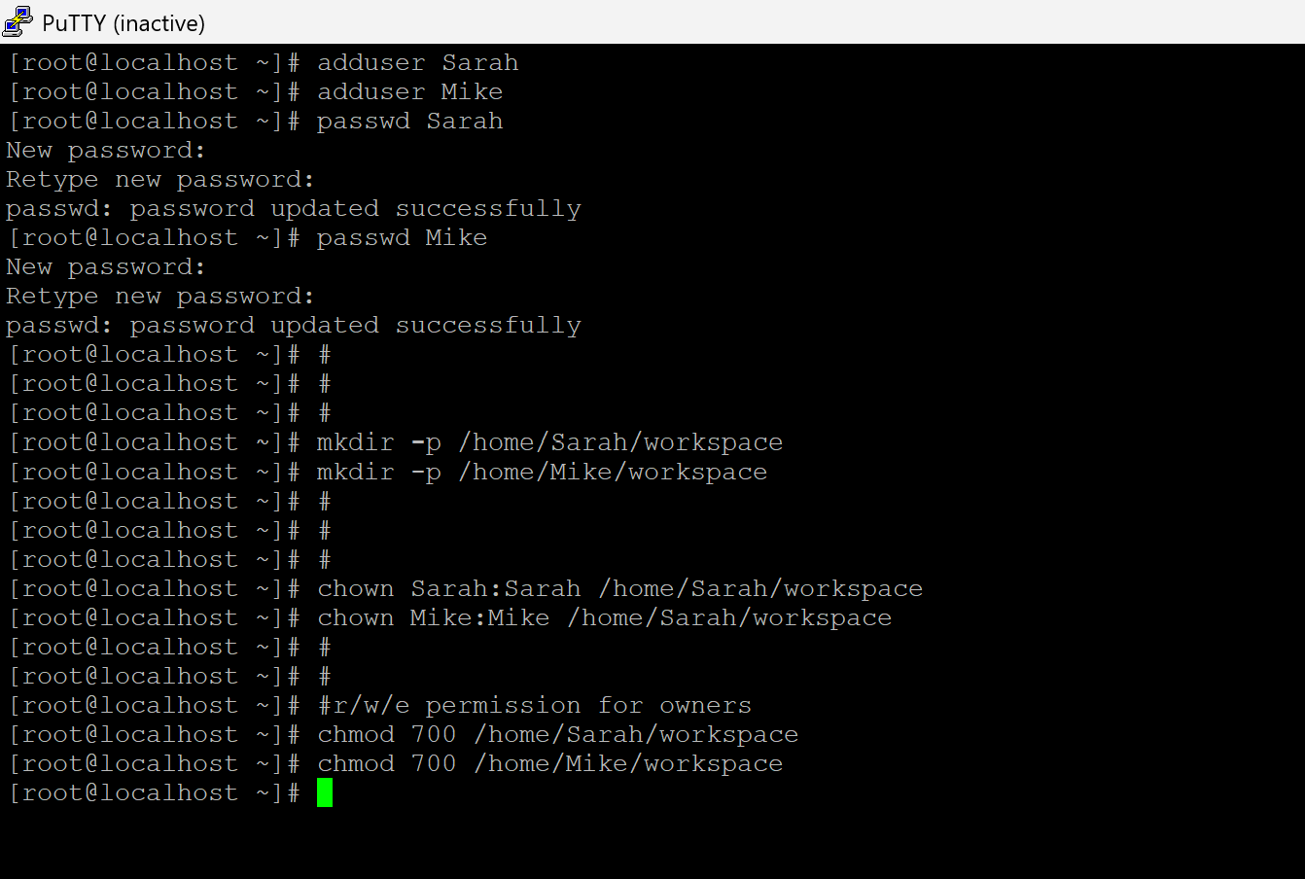

- Enforce Password Policy
  - Install password policy tool
    - yum install -y libpwquality
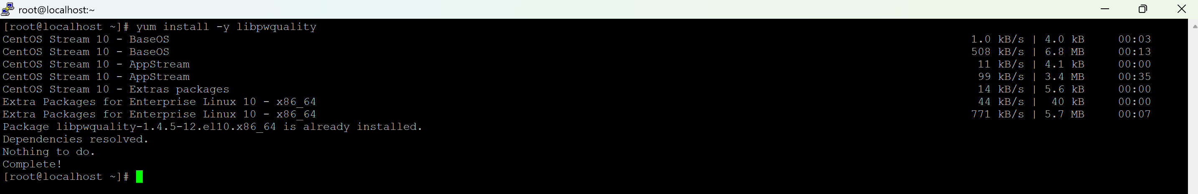
- Edit PAM password policy:
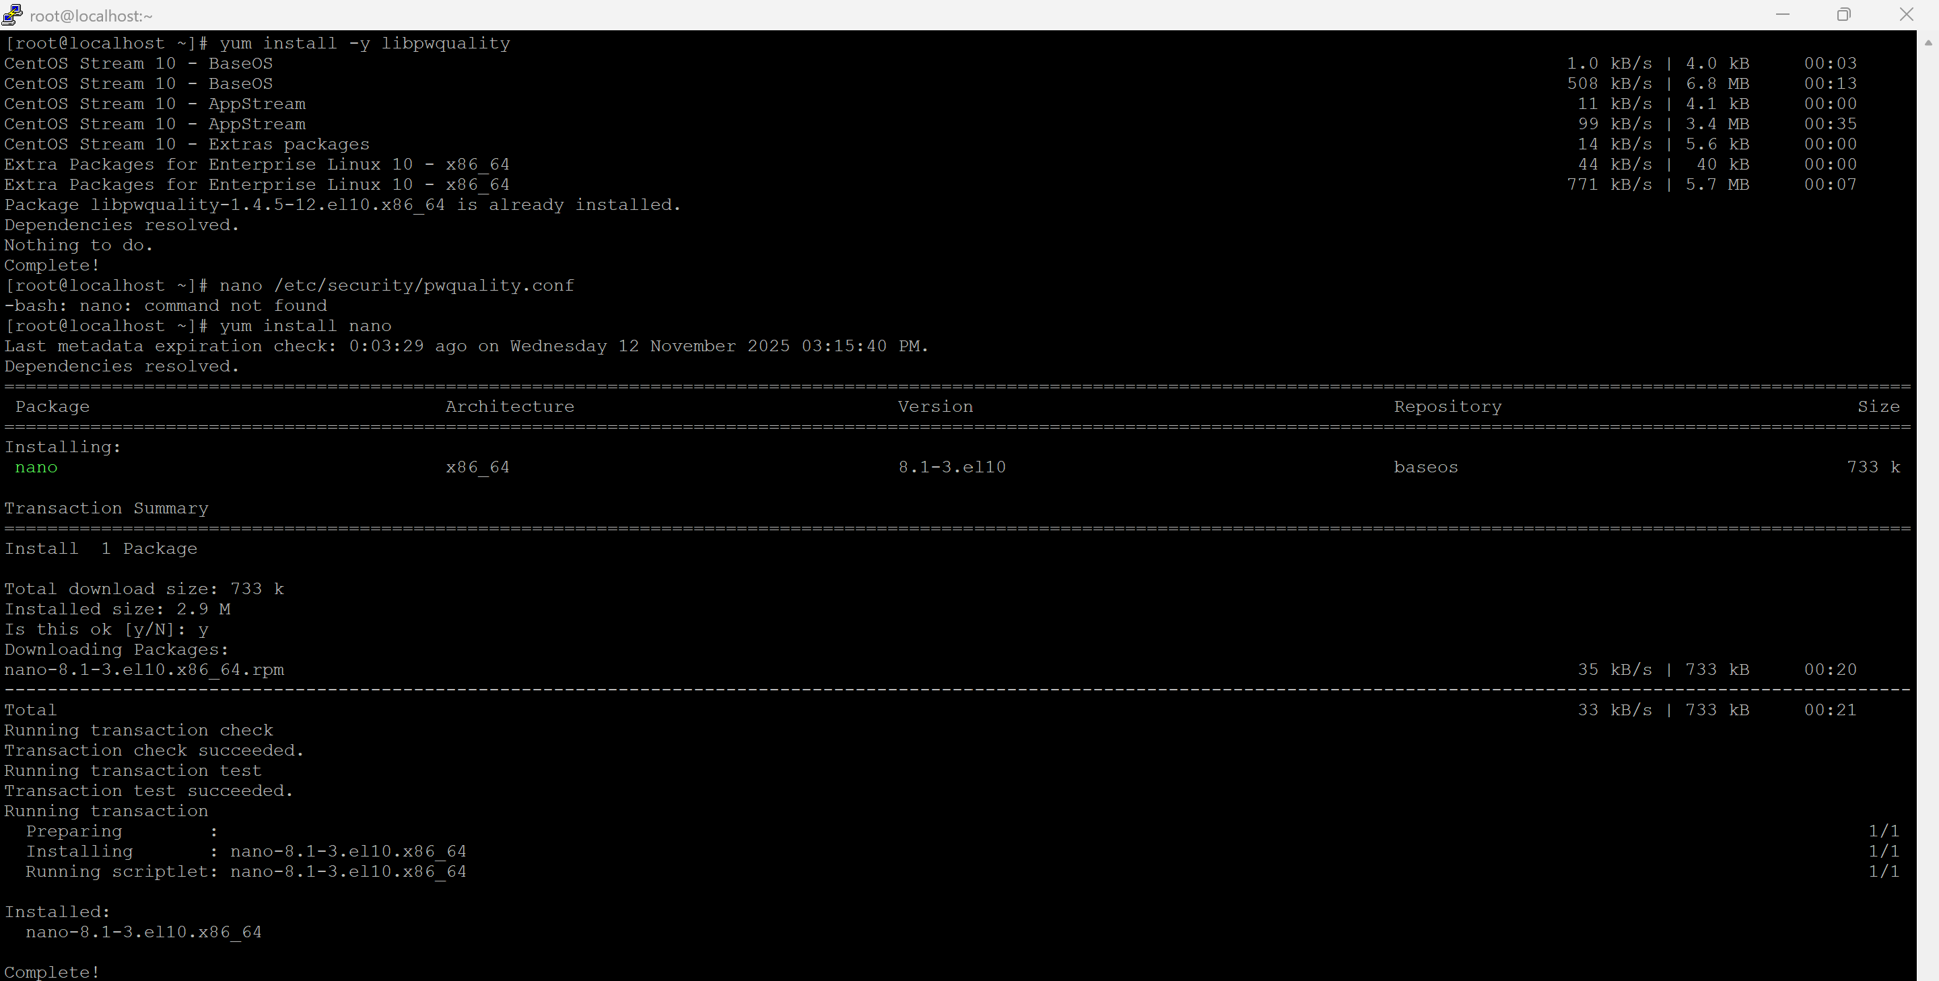
  - Change minlen, minclass, maxrepeat
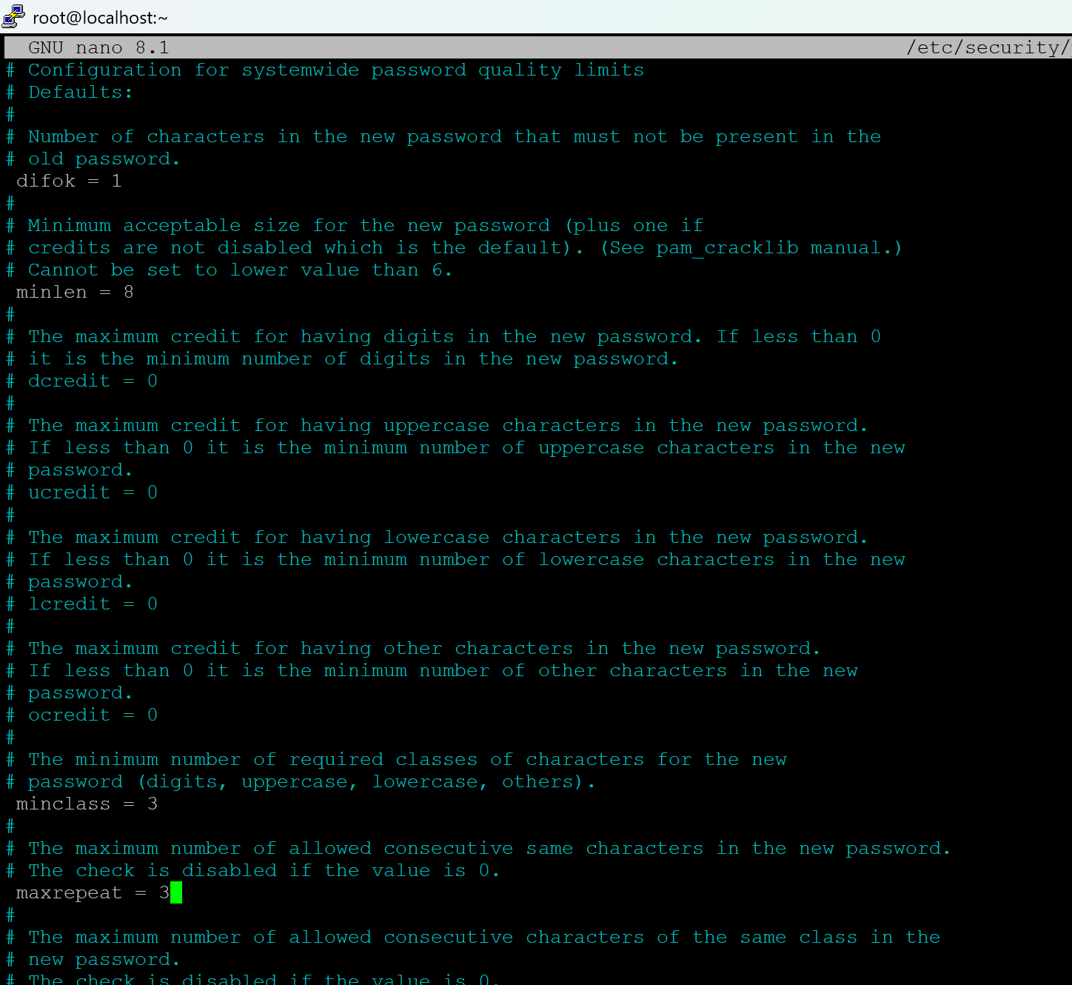

- Set password expiration:
  - chage -M 30 Sarah
  - chage -M 30 Mike

- Verify/test new users:

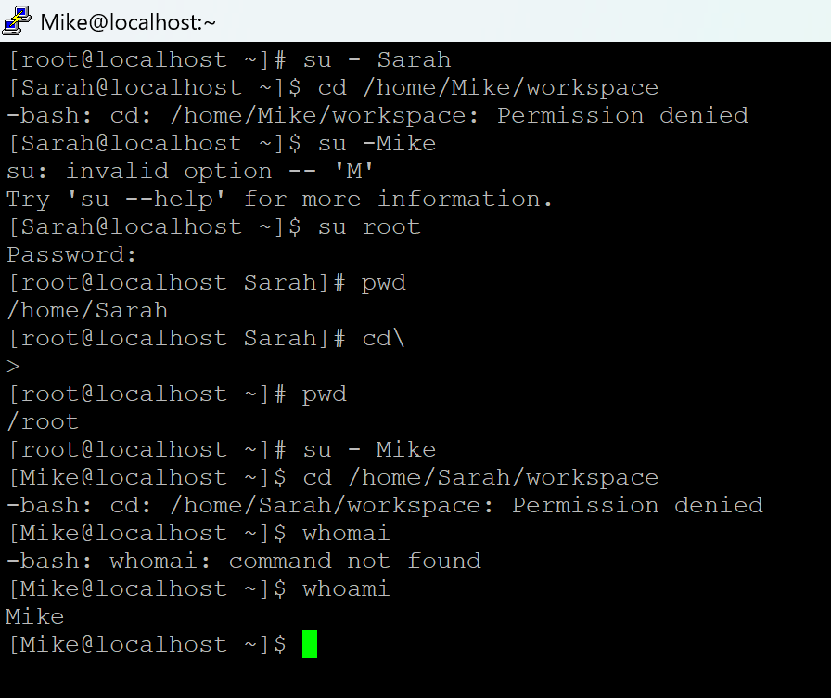

Verify Password policy:
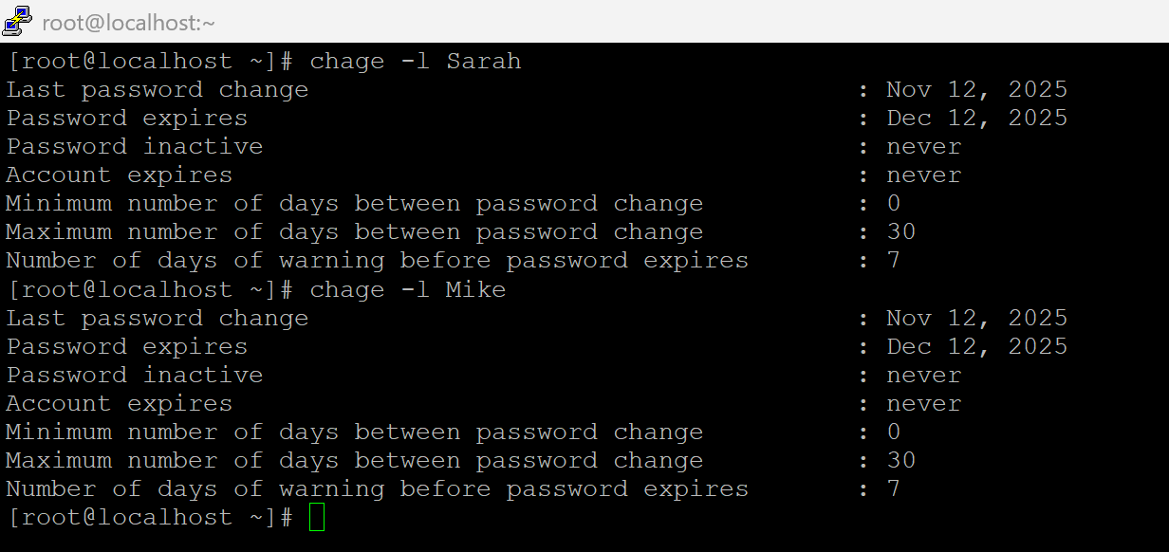

Task 3 — Backup Configuration for Web Servers
Objective: Automate weekly ( Tuesday 00:00 ) backups for Apache (Sarah) and Nginx (Mike).
- Install Web Servers
  - yum install -y httpd
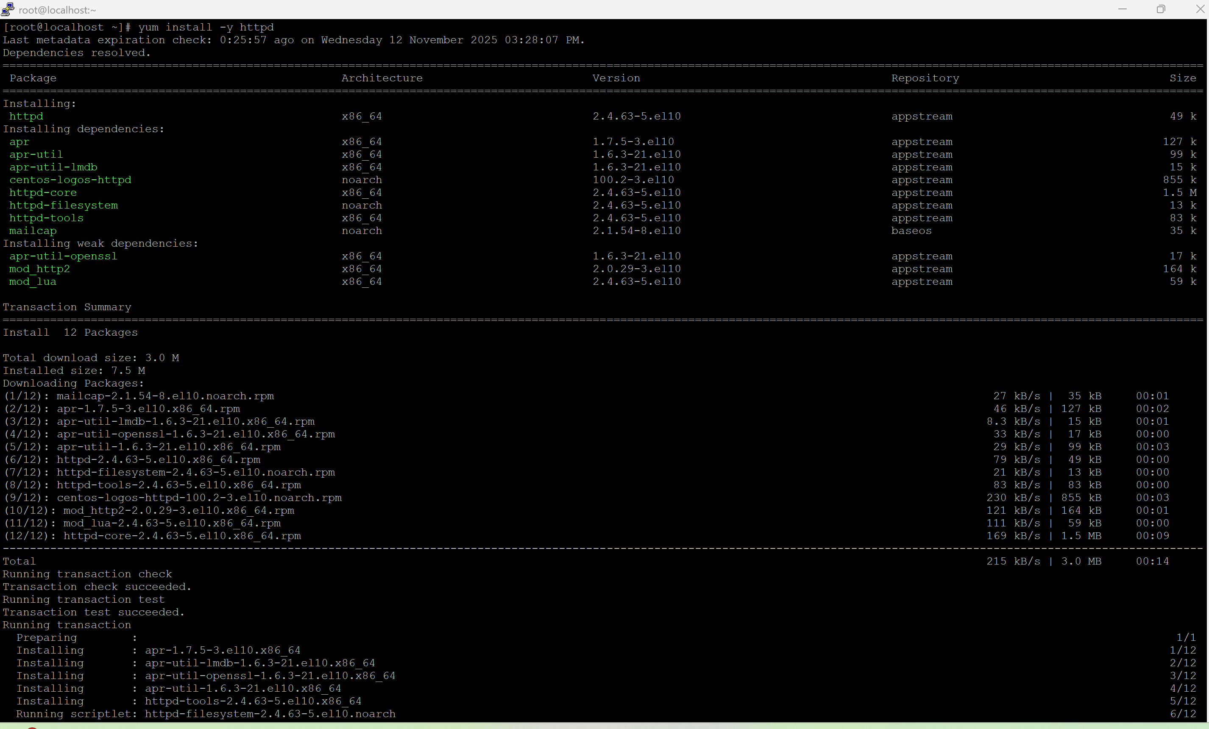
  - yum install -y nginx
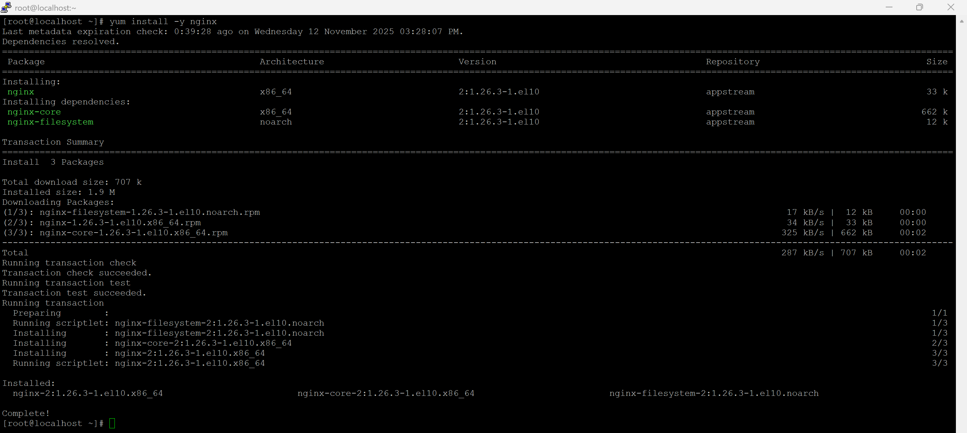
  - systemctl enable --now nginx
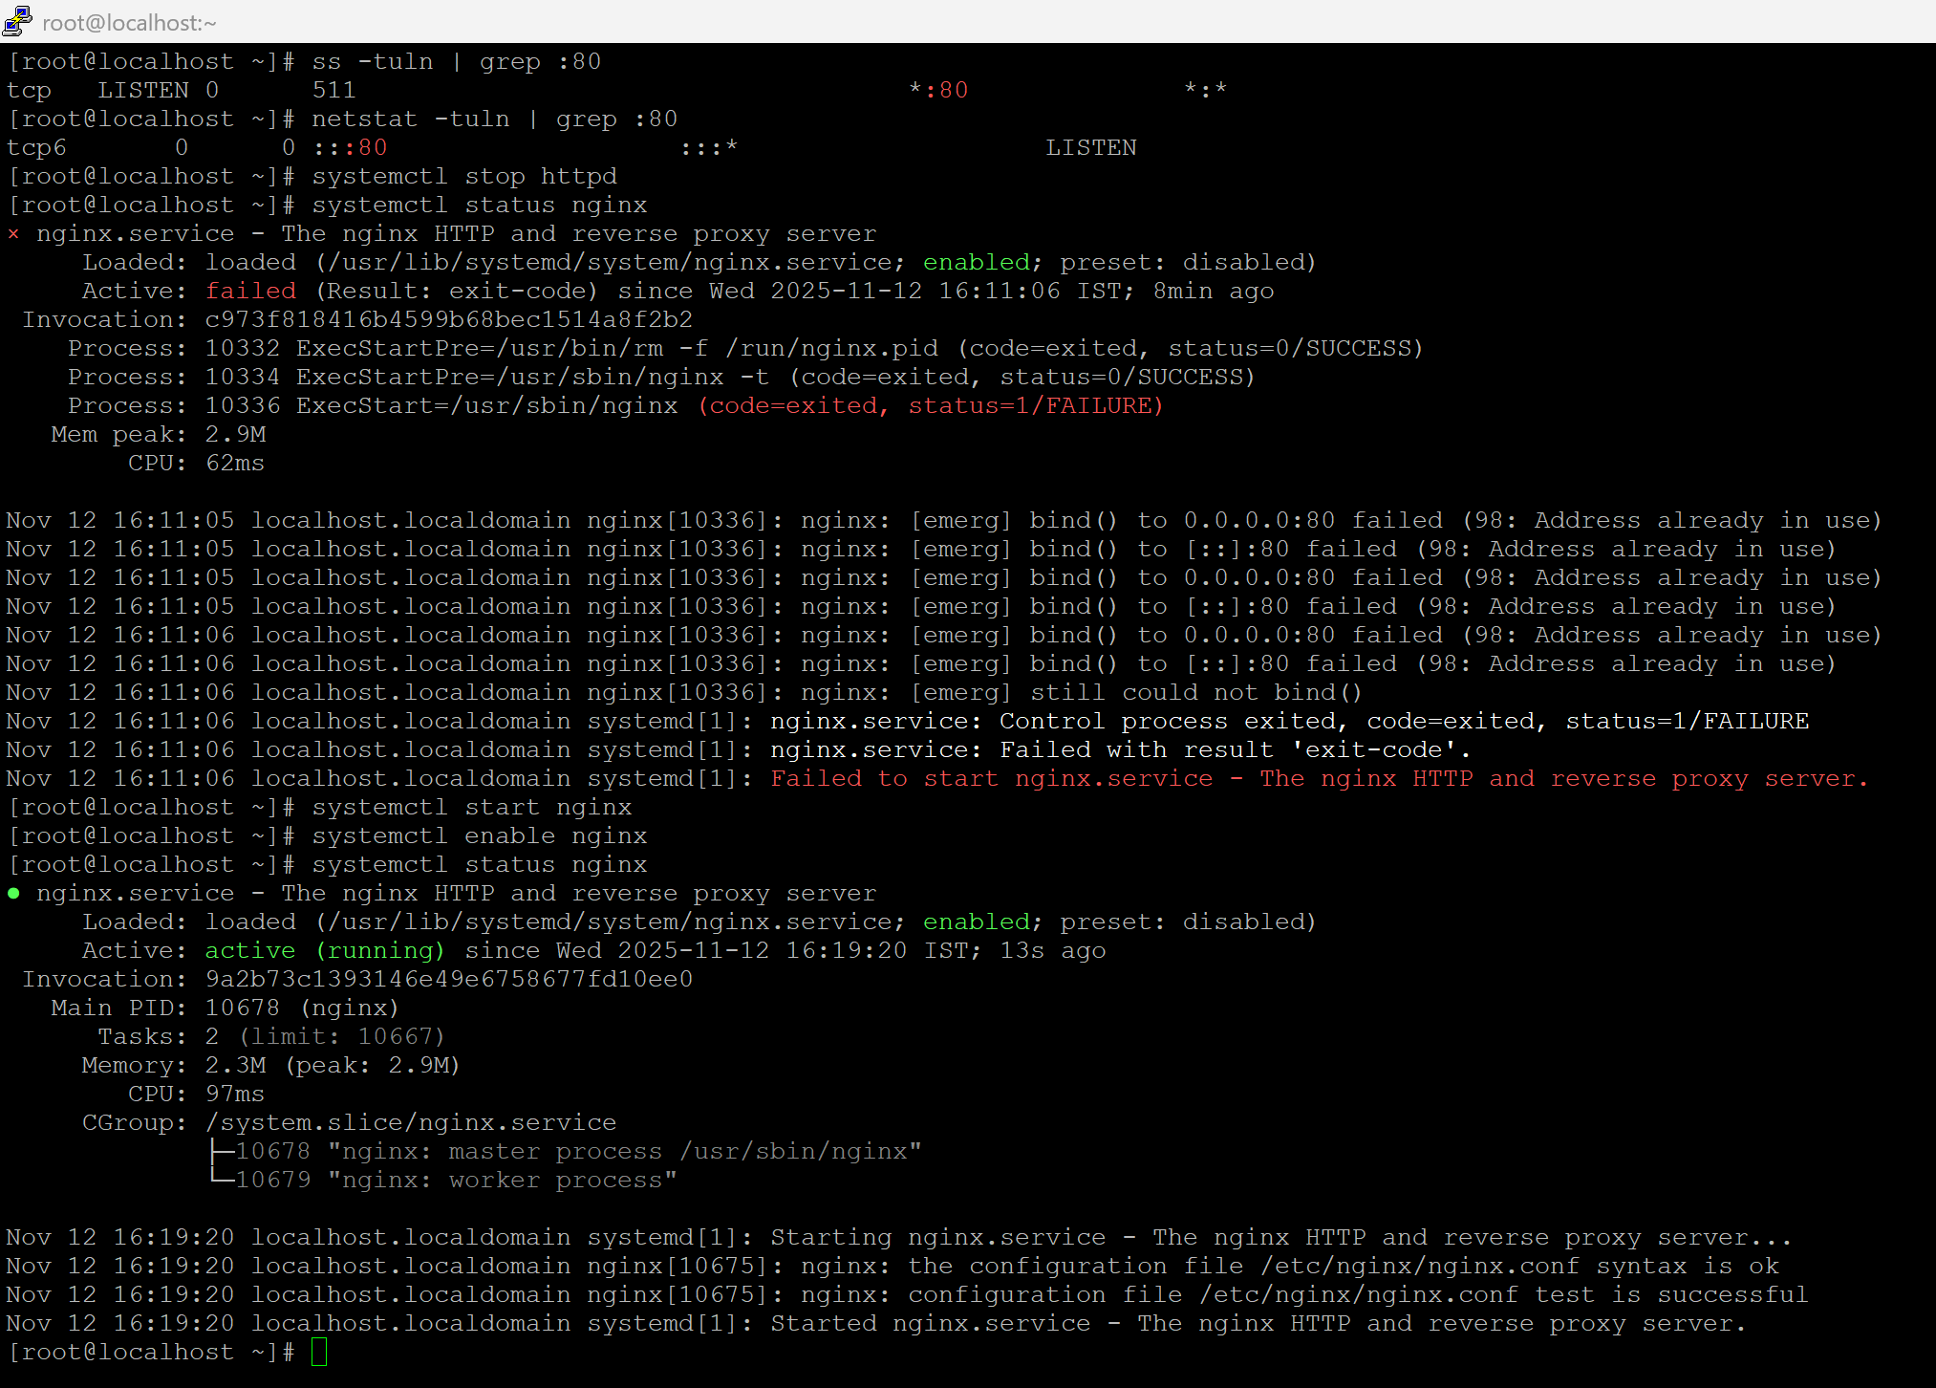
  - systemctl enable --now httpd
    - change port for httpd as port 80 is default for both httpd and nginx
    - nano /etc/httpd/conf/httpd.conf
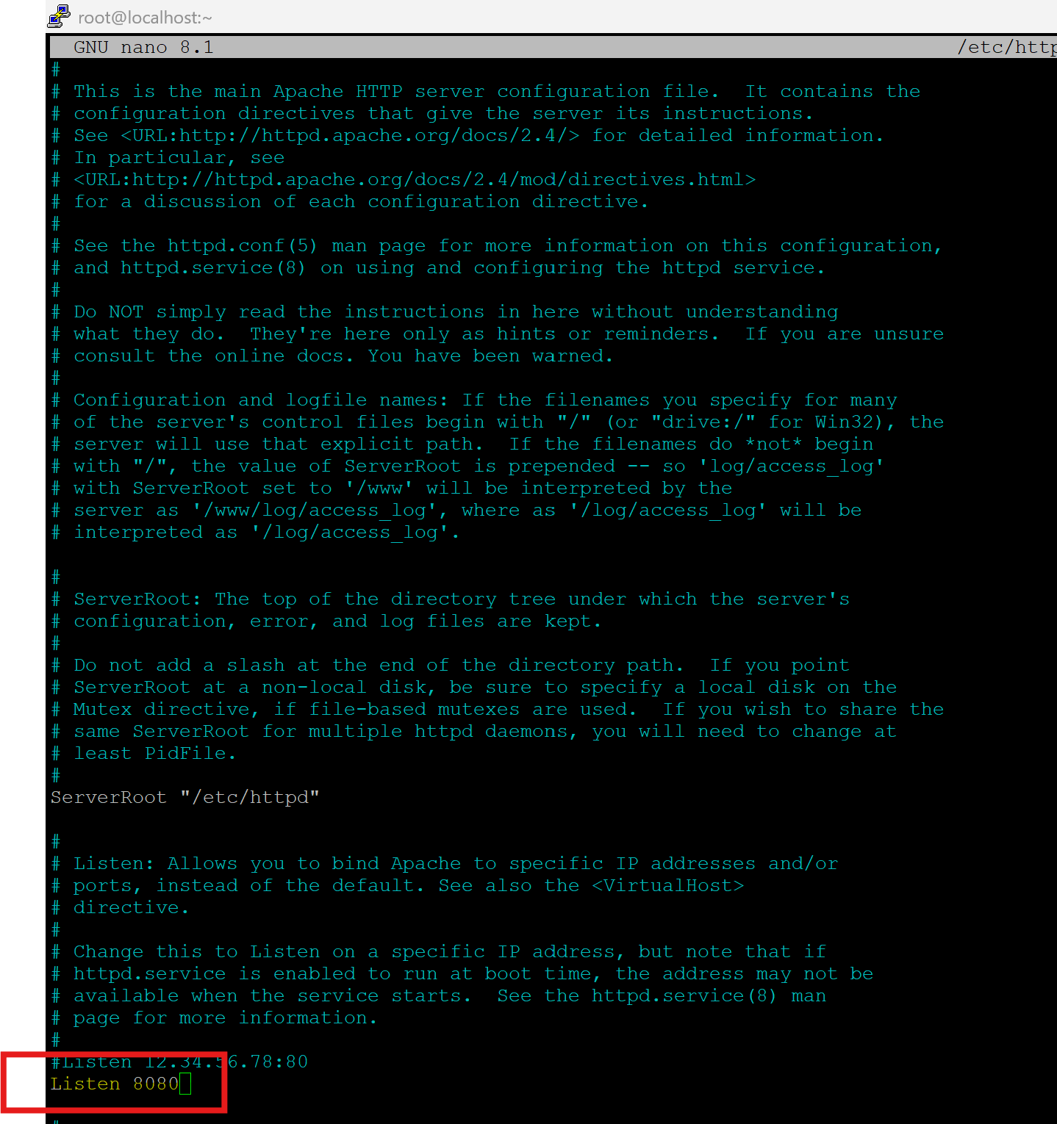

    - Restart and Check status of httpd
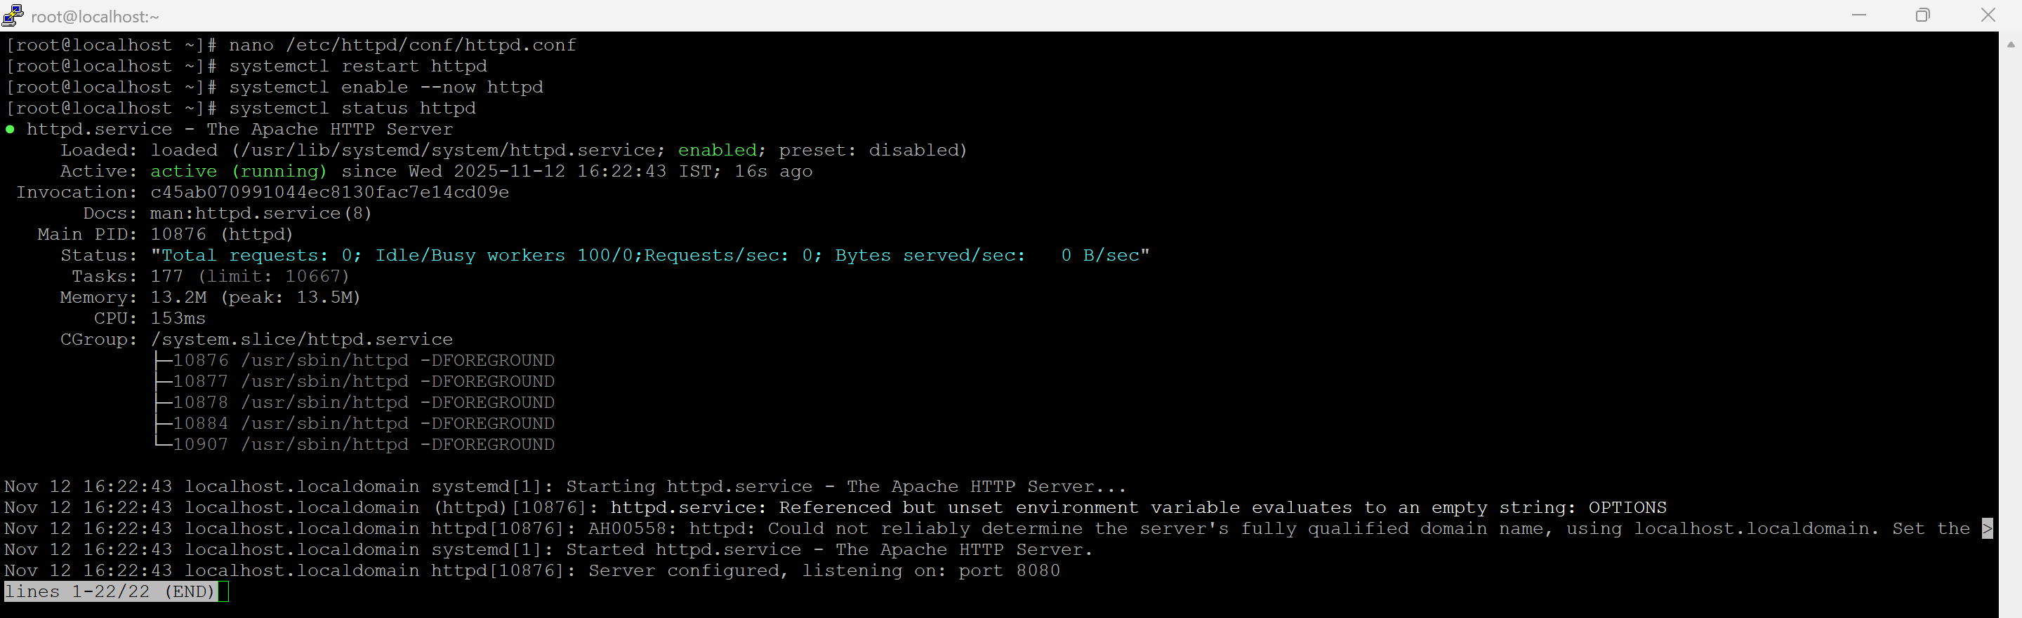
- Create Backup Directory
  - mkdir -p /backups
- Apache Backup Script
  - nano /usr/local/bin/apache_backup.sh
#!/bin/bash
DATE=$(date +%F)
BACKUP_FILE="/backups/apache_backup_${DATE}.tar.gz"
tar -czf $BACKUP_FILE /etc/httpd/ /var/www/html/
tar -tzf $BACKUP_FILE > /backups/apache_backup_verify_${DATE}.log

  - Make executable: chmod +x /usr/local/bin/apache_backup.sh
- Nginx Backup Script
  - nano /usr/local/bin/nginx_backup.sh
#!/bin/bash
DATE=$(date +%F)
BACKUP_FILE="/backups/nginx_backup_${DATE}.tar.gz"
tar -czf $BACKUP_FILE /etc/nginx/ /usr/share/nginx/html/
tar -tzf $BACKUP_FILE > /backups/nginx_backup_verify_${DATE}.log

  - Make executable: chmod +x /usr/local/bin/nginx_backup.sh
- Schedule Cron Jobs
  - Open cron table:
    - crontab -e
Add:
Weekly backups scripts to be executed(Tuesday 00:00)
0 0 * * 2 /usr/local/bin/apache_backup.sh
0 0 * * 2 /usr/local/bin/nginx_backup.sh

  - manually run the script and verify
